CRM LEADS, MARKETING &
SALES PERFORMANCE
ANALYSIS SYSTEM
Complete Technical & Business Documentation

Project: CRM Leads, Marketing & Sales Performance Analysis System
Primary Tools: CSV / Excel, Python, PostgreSQL, Power Query, Power BI, DAX
Document Type: Final Project Documentation
Date: October 2026

1. Executive Summary
The CRM Leads, Marketing & Sales Performance Analysis System is a business intelligence project designed to analyze lead generation, marketing performance, sales conversion, lead quality, follow-up activities, and revenue performance.
The project uses CSV/Excel files as source data, Python for data inspection and cleaning, PostgreSQL for relational storage and SQL analysis, Power Query for transformation, Power BI for interactive dashboards, and DAX for KPI calculations.
The report contains three dashboard pages: Management Overview, Marketing Performance, and Lead Funnel and Quality. The screenshots display 10,000 total leads, 197 closed-won leads, a 1.97% conversion rate, approximately 1.58M in won revenue, 5,823 lost leads, and 1,239 follow-ups.
The objective is to turn CRM records into actionable insights and help management investigate lead qualification, marketing attribution, sales follow-up, conversion performance, and data-quality gaps.

2. Project Overview
The project combines marketing and sales reporting in a single interactive Power BI report. Users can filter the report by lead date, lead source, lead owner, lead stage, district, domain, lead quality, and campaign.
- Lead volume and conversion outcomes
- Marketing channel, campaign, and ad-set distribution
- Monthly lead and revenue trends
- Sales funnel progression and lost leads
- Lead quality and call activity
- Revenue by district, source, and business domain
- Follow-up opportunities and reporting gaps

3. Business Problem
CRM data can be spread across many records, sources, campaigns, owners, stages, locations, and contact activities. Manual reporting makes it difficult to compare performance consistently and identify where leads are being lost.
- Limited visibility into lead generation and conversion
- Difficulty comparing marketing channels and campaigns
- Inconsistent classification of lead stages and outcomes
- Limited visibility into lead quality and follow-up activity
- Difficulty identifying high-performing districts and domains
- Time-consuming manual reporting
- No single view combining marketing and sales performance

4. Project Objectives
- Inspect, clean, and validate CRM data before analysis
- Use Python for data inspection and exploratory data analysis
- Use PostgreSQL for structured storage and SQL analysis
- Transform and standardize data with Power Query
- Build a reliable Power BI data model
- Create business KPIs using DAX
- Analyze leads by source, campaign, ad set, owner, stage, district, and domain
- Monitor lead quality, call activity, and follow-ups
- Identify possible sales-funnel bottlenecks
- Present findings and recommendations through interactive dashboards

5. System Architecture
The logical end-to-end workflow is: CSV/Excel Source Data → Python Inspection and Cleaning → PostgreSQL Relational Storage and SQL Analysis → Power BI → Power Query → Power BI Data Model → DAX Measures → KPI Framework → Interactive Dashboards → Business Analysis and Management Decisions.

Overall Concept

Complete System Architecture Model
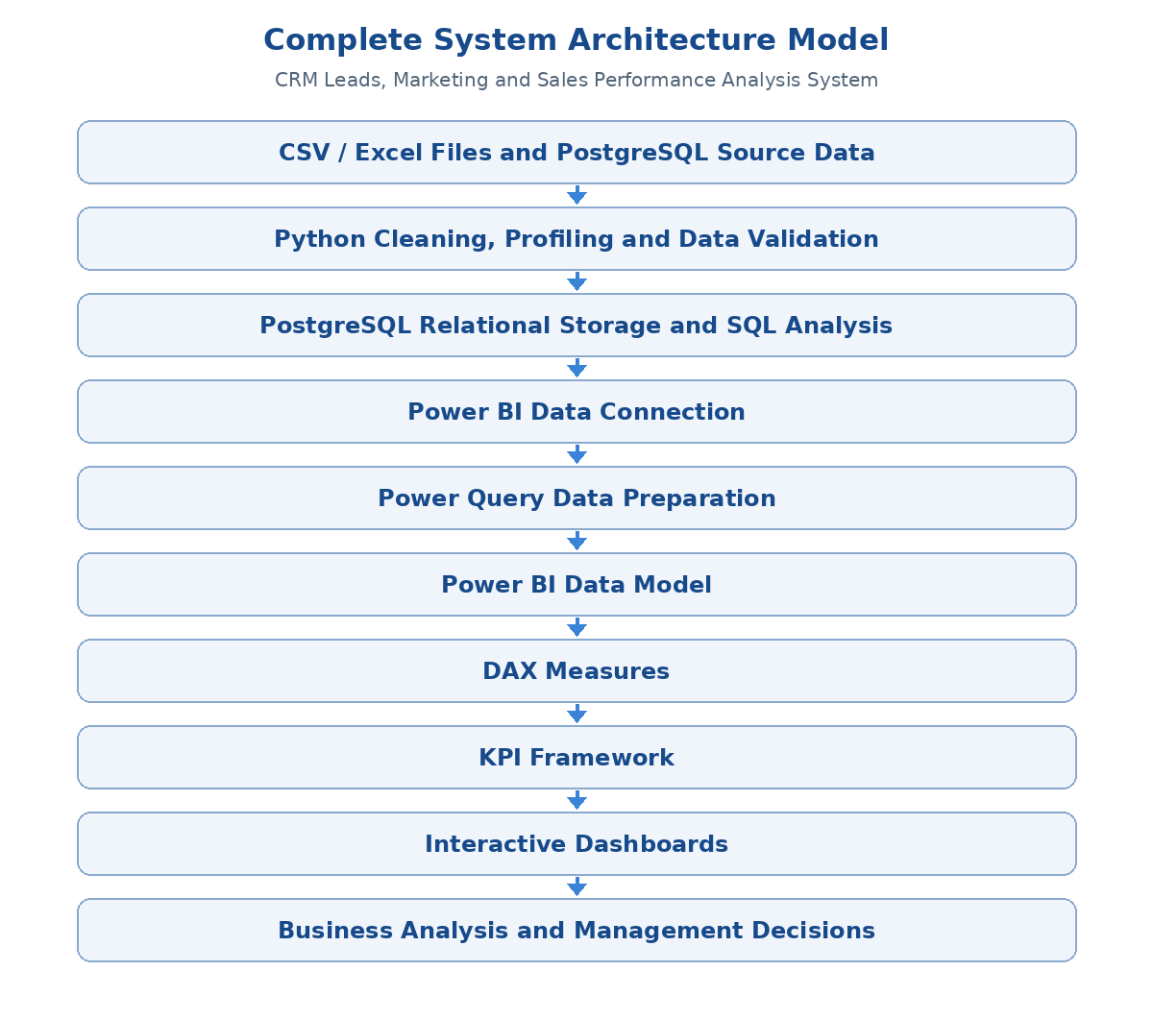
Figure: End-to-end architecture for the CRM analytics project
The model reflects the intended workflow across source files, Python, PostgreSQL, Power BI, Power Query, DAX, dashboards, and business analysis. The final connector path should match the actual configured data sources.
CSV/Excel provides the source records. Python supports inspection, cleaning, validation, and exploratory analysis. PostgreSQL supports structured storage and SQL queries. Power Query prepares data for the semantic model. Power BI hosts the model, filters, and visuals. DAX calculates the KPIs and analytical measures.
Implementation note: the final architecture diagram should reflect the actual connection path. If Power BI reads a CSV/Excel file directly, PostgreSQL should only be shown as an active Power BI source if that connection was configured in the implemented project.

6. Tools and Technologies
Technology | Role in the project
CSV / Excel | Source-data files and initial data review
Python | Data inspection, cleaning, validation, and exploratory analysis
PostgreSQL | Relational data storage, SQL queries, and result validation
Power Query | Data cleaning, type conversion, and transformation
Power BI | Data model, interactive visuals, slicers, and reporting
DAX | KPI calculations, ratios, totals, and analytical measures

7. Data Requirements and Dataset Structure
The CRM dataset includes information about lead identity, dates, marketing, sales activity, revenue, lead quality, geography, and business interest. Exact column names should be verified against the final source file.
Data category | Example fields | Analytical purpose
Identification | Lead ID, Lead Title | Identify and count leads
Dates | Lead Date, Won Date | Trend and outcome analysis
Marketing | Lead Source, Campaign, Ad Set, Ad Name | Compare acquisition sources
Sales ownership | Lead Owner | Review allocation and owner performance
Funnel | Lead Stage, Qualification | Monitor stage progression
Lead quality | Lead Quality | Understand qualification patterns
Call activity | Call status, follow-up fields | Review outreach activity
Revenue | Won Revenue | Measure successful business value
Geography | District, City, State | Regional analysis
Business interest | Domain Interested | Segment leads by interest

8. Data Preparation Using Python
Python is used to inspect source data and support data-quality checks before dashboard development.
- Load the CSV/Excel dataset with pandas.
- Inspect row counts, column names, and data types.
- Identify missing values and duplicate records.
- Check date and numeric fields for invalid values.
- Review inconsistent category names and whitespace.
- Explore lead stages, marketing sources, lead quality, and revenue.
- Compare record counts before and after cleaning.
- Export prepared data when required by the workflow.
Missing values should be handled according to their business meaning. For example, a missing lead-quality label should not automatically be treated as poor quality. An Unknown category may be appropriate when the classification was not recorded.

9. Data Storage and PostgreSQL
PostgreSQL provides a relational storage layer and supports SQL-based aggregation, filtering, and validation. The table and column names in example queries must match the implemented schema.
SELECT lead_source, COUNT(*) AS total_leads
FROM crm_leads
GROUP BY lead_source
ORDER BY total_leads DESC;
Example: summarize won revenue by district.
SELECT district, SUM(won_revenue) AS total_won_revenue
FROM crm_leads
WHERE won_revenue IS NOT NULL
GROUP BY district
ORDER BY total_won_revenue DESC;
SQL results can be compared with Power BI totals to help identify inconsistencies in counting, filters, and aggregation.

10. Power BI Data Connection
- Select the configured CSV/Excel or PostgreSQL source.
- Load the required tables.
- Review column names and data types.
- Open Power Query to prepare the data.
- Apply transformations and load the prepared data.
- Configure relationships in the data model.
- Create DAX measures.
- Develop dashboard visuals, slicers, and navigation.
- Validate displayed values against source data or SQL/Python checks.
For file-based sources, the file path must remain accessible for refresh. For PostgreSQL, server, database, credentials, and permissions must be configured correctly.

Operational System and Data Separation Model
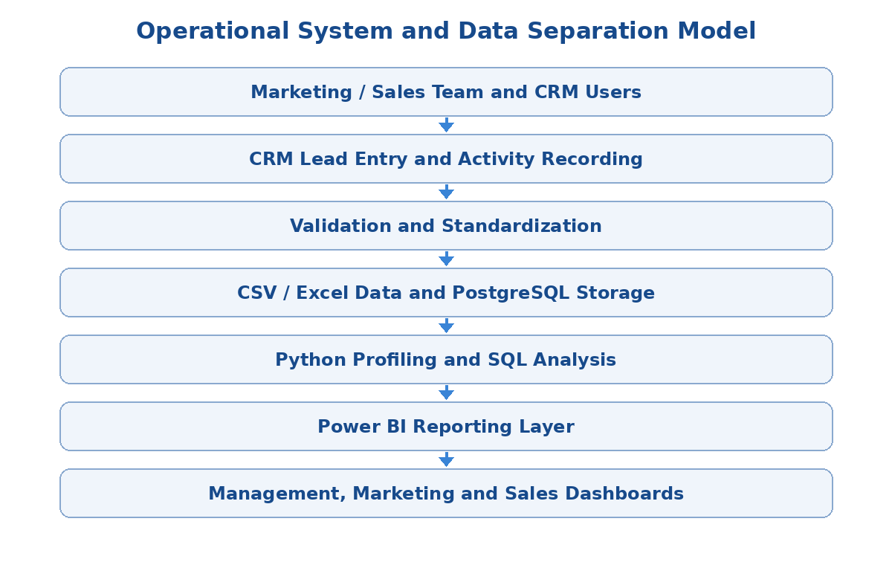
Figure: Separation between CRM operations, data preparation, and BI reporting
This is a logical view of the project workflow, not a claim that a separate CRM form application was built.

11. Power Query Data Preparation
- Assign correct date, numeric, and text data types
- Trim unnecessary spaces and standardize category names
- Investigate duplicate lead identifiers
- Handle blanks and missing values consistently
- Check revenue fields for invalid values
- Review date formats and month ordering
- Investigate unexpected lead-stage categories
- Compare record counts before and after transformations
Valid records should not be removed without a clear reason. Important transformations should be documented so that data preparation remains understandable and repeatable.

12. Power BI Data Model
A basic implementation can use a central CRM leads table containing lead identifiers, dates, source, owner, stage, quality, campaign, district, and revenue. Where the source supports it, separate dimension tables may be used for dates, marketing sources, campaigns, districts, owners, and stages.
- Confirm whether each row represents one lead or one activity
- Use unique lead identifiers where available
- Prevent duplicate counting caused by repeated records
- Create a dedicated date table when appropriate
- Sort month names by month number
- Check relationship cardinality and filter direction
- Test the model using known totals
- Organize DAX measures with clear names
The final relationship diagram should represent the actual Power BI model rather than an assumed schema.

Implemented Power BI Relationship Model
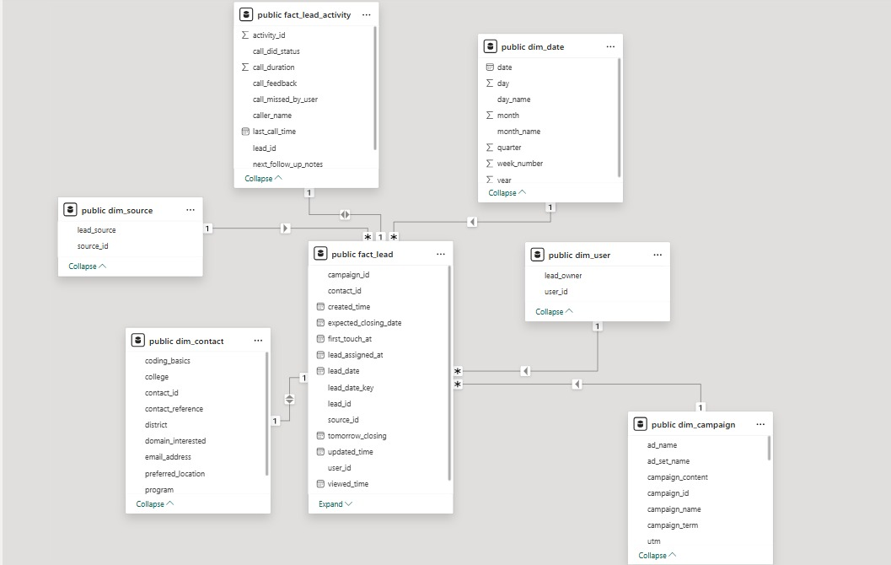
Figure: Power BI model screenshot supplied for the CRM project
The model screenshot shows public.fact_lead at the center, linked to public.dim_source, public.dim_contact, public.dim_date, public.dim_user, and public.dim_campaign. It also shows public.fact_lead_activity linked with the lead data. Validate relationship cardinalities, filter directions, and key uniqueness in the PBIX before final submission.

13. KPI Framework
KPI | Displayed value | Business purpose
Total Leads | 10,000 | Measures displayed lead volume
Total Won Revenue | 1.58M | Summarizes displayed won revenue
Closed Won Leads | 197 | Counts successful outcomes
Conversion Rate | 1.97% | Won leads as a proportion of total leads
Lost Leads | 5,823 | Measures displayed lost outcomes
Total Follow Ups | 1,239 | Displays follow-up count

These values are taken from the supplied dashboard screenshots and should be validated against the final dataset and measures. Confirm the revenue currency and the counting logic used for follow-ups.

14. DAX and Analytical Measure Layer
The following formulas are illustrative examples. They assume a table named CRM Leads and field names that match the actual model. They are not verified copies of the existing PBIX measures.
Total Leads =
DISTINCTCOUNT('CRM Leads'[Lead ID])
Closed Won Leads =
CALCULATE(
[Total Leads],
'CRM Leads'[Lead Stage] = "CLOSED WON"
)
Lost Leads =
CALCULATE(
[Total Leads],
'CRM Leads'[Lead Stage] = "CLOSED LOST"
)
Conversion Rate =
DIVIDE([Closed Won Leads], [Total Leads], 0)
Total Won Revenue =
SUM('CRM Leads'[Won Revenue])
Format Conversion Rate as a percentage. If multiple rows can exist for one lead, measures should avoid double-counting.

15. Dashboard Structure
The Power BI report contains three pages: Management Overview, Marketing Performance, and Lead Funnel and Quality. Each page includes slicers for dimensions such as lead date, source, owner, stage, district, domain, lead quality, and campaign.
Slicers allow users to examine selected periods, sources, owners, and other business segments. KPI totals may change based on the current filter context.

16. Executive Dashboard — Management Overview
The Management Overview provides a high-level view of CRM and business performance.
- Total Won Revenue, Total Leads, Closed Won Leads, and Conversion Rate
- Monthly Revenue
- Leads by District
- Revenue by Domain of Interest
- Revenue by Lead Source
- Closed-Won Leads by Campaign
Business purpose: help management monitor lead volume, won revenue, conversion outcomes, geographic distribution, and campaign-related results. Management can start with KPI cards, identify unusual chart patterns, and apply filters to investigate specific sources, owners, stages, or districts.
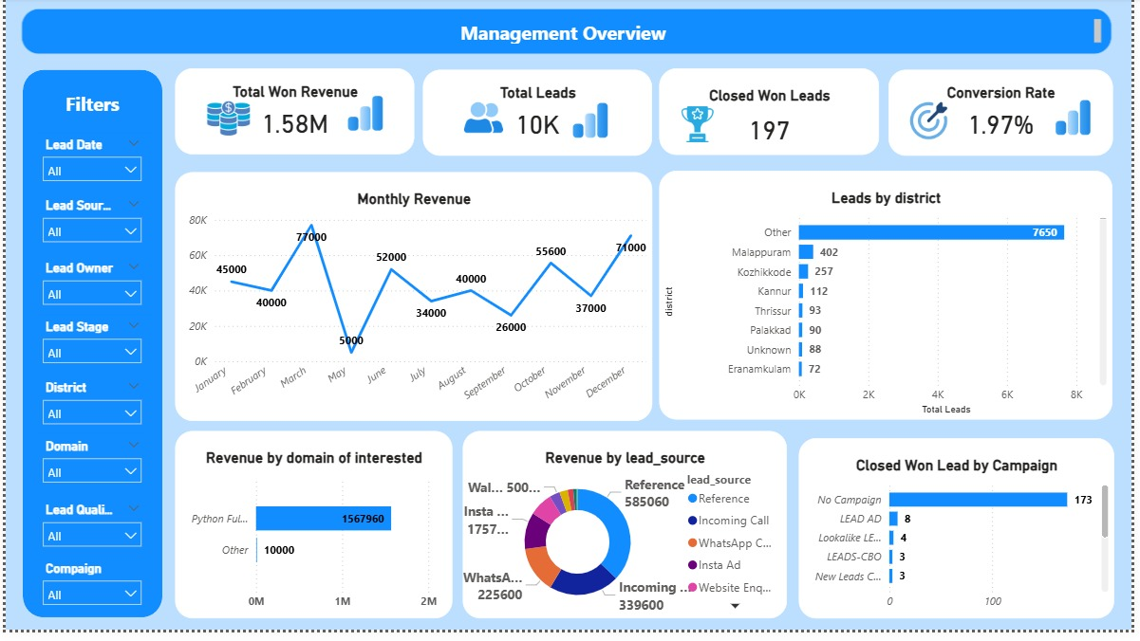
Figure 1. Management Overview Dashboard

17. Marketing Performance Dashboard
The Marketing Performance dashboard focuses on lead acquisition and marketing distribution.
- Total Leads, Total Won Revenue, Closed Won Leads, and Conversion Rate
- Leads by Marketing Channel
- Monthly Lead Trend
- Leads by Ad Set
- Revenue by District
Lead volume alone does not establish marketing effectiveness. A stronger evaluation compares volume with closed-won leads, conversion rate, revenue, and advertising cost where available.
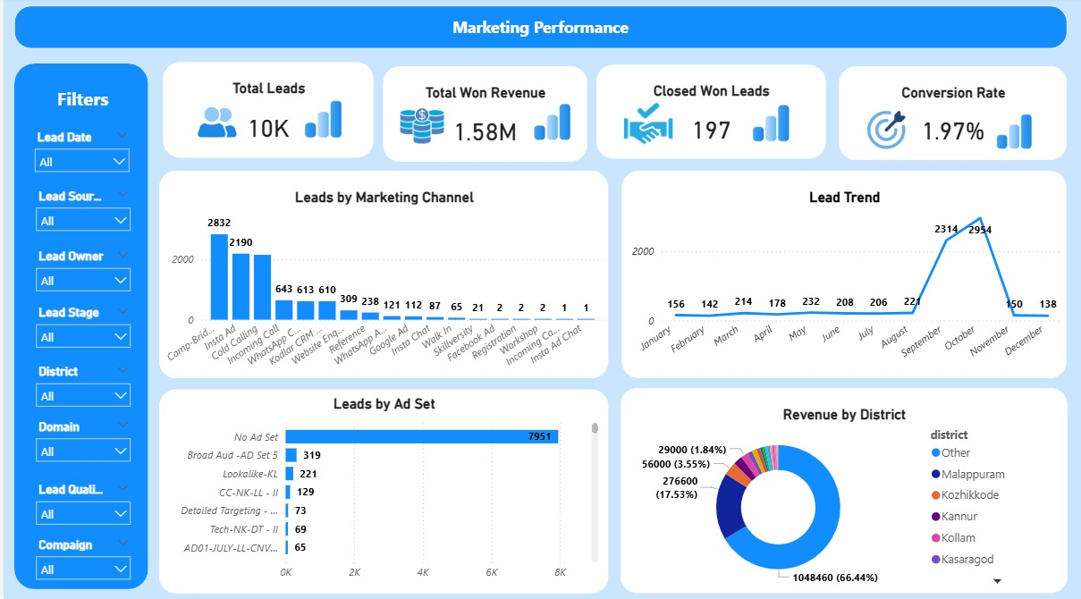
Figure 2. Marketing Performance Dashboard

18. Lead Funnel and Quality Dashboard
The Lead Funnel and Quality dashboard evaluates lead stages, quality classifications, and call activity.
- Total Leads, Lost Leads, Closed Won Leads, and Total Follow Ups
- Lead Quality Score
- Call Activity Status
- Lead by Stage
The screenshot displays 6,089 leads in the Unknown quality category and 5,501 records under Untouched call activity status. These values indicate areas to investigate; they do not independently establish why the classification or activity status occurred.
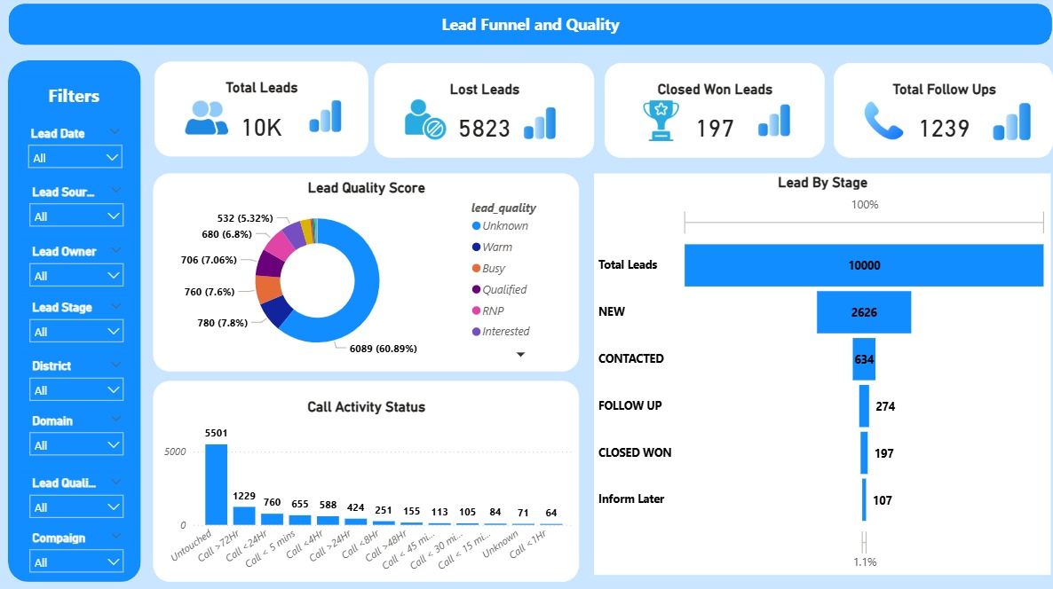
Figure 3. Lead Funnel and Quality Dashboard

19. Business Analysis and Key Findings
No. | Finding from dashboard | Business interpretation
1 | 10,000 total leads | The report supports segmentation across marketing and sales dimensions.
2 | 197 closed-won leads | Successful outcomes are small relative to total lead volume.
3 | 1.97% conversion rate | Lead progression and qualification deserve investigation.
4 | 1.58M displayed won revenue | Provides a high-level view of successful business outcomes.
5 | 5,823 lost leads | Analyze lost outcomes by reason, source, owner, and stage.
6 | 6,089 Unknown-quality leads (60.89%) | Many records lack a more specific displayed quality classification.
7 | 5,501 Untouched call-activity records (about 55%) | Initial outreach and activity recording need investigation.
8 | 7,951 leads under No Ad Set | Attribution may be missing, unavailable, or grouped under a default category.
9 | 7,650 leads under Other district | The broad grouping limits detailed geographic analysis.
10 | 173 closed-won leads under No Campaign | Campaign attribution for won leads may need improvement.
11 | Monthly lead counts vary substantially, with spikes in September and October | Investigate campaign changes, duplicates, reporting periods, and data completeness.
12 | Python Full Stack domain displays the largest revenue contribution | Compare the domain's lead volume, conversion, and revenue with other domains.

The detailed monthly revenue visual shows values including March 77,000 and December 71,000, with a low displayed May value of 5,000. April appears to be missing from the visual and should be checked against the date table, filters, and chart configuration. Revenue currency should be confirmed before labeling these figures with a currency symbol.

20. Recommendations

20.1 Improve Lead Quality Classification
- Investigate why so many leads are marked Unknown.
- Define consistent criteria for Warm, Qualified, Interested, Busy, and RNP.
- Encourage updates to lead quality after relevant interactions.
- Monitor the percentage of leads with completed quality assessments.

20.2 Improve Follow-up Tracking
- Review records marked Untouched.
- Confirm the meaning of each call-activity status.
- Standardize recording of call attempts and follow-up outcomes.
- Monitor time from lead creation to first contact.
- Identify leads that require follow-up action.

20.3 Improve Marketing Attribution
- Investigate the high number of leads under No Ad Set.
- Review No Campaign records among closed-won leads.
- Standardize campaign, ad-set, and source naming.
- Compare channels using leads, wins, conversion rate, and revenue.
- Add marketing-cost analysis if reliable cost data becomes available.

20.4 Improve Sales Conversion
- Review progression between New, Contacted, Follow Up, and Closed Won.
- Identify stages where leads stop progressing.
- Analyze lost reasons by source, owner, and quality.
- Compare conversion performance across channels and domains.

20.5 Improve Geographic Reporting
- Investigate the rules used to group districts under Other.
- Standardize district names and review missing location data.
- Preserve detailed location information where available and appropriate.

20.6 Strengthen Data Quality and KPI Reliability
- Validate the total number of unique leads.
- Confirm whether records represent leads or activities.
- Reconcile revenue totals with source data.
- Verify conversion-rate definitions and filter context.
- Test dashboard calculations against SQL or Python results.

21. Dashboard Usage and Business Decision-Making
User group | Dashboard use
Management | Monitor total leads, revenue, conversion, and regional performance
Marketing team | Compare sources, campaigns, and ad sets
Sales team | Review lead stages, quality, call activity, and follow-up
Data analysts | Validate calculations and investigate unusual patterns

A typical workflow is to begin with Management Overview, explore acquisition patterns in Marketing Performance, and investigate funnel progression and contact activity in Lead Funnel and Quality. Users should check active filters before comparing KPIs.

Reporting Navigation and Investigation Model
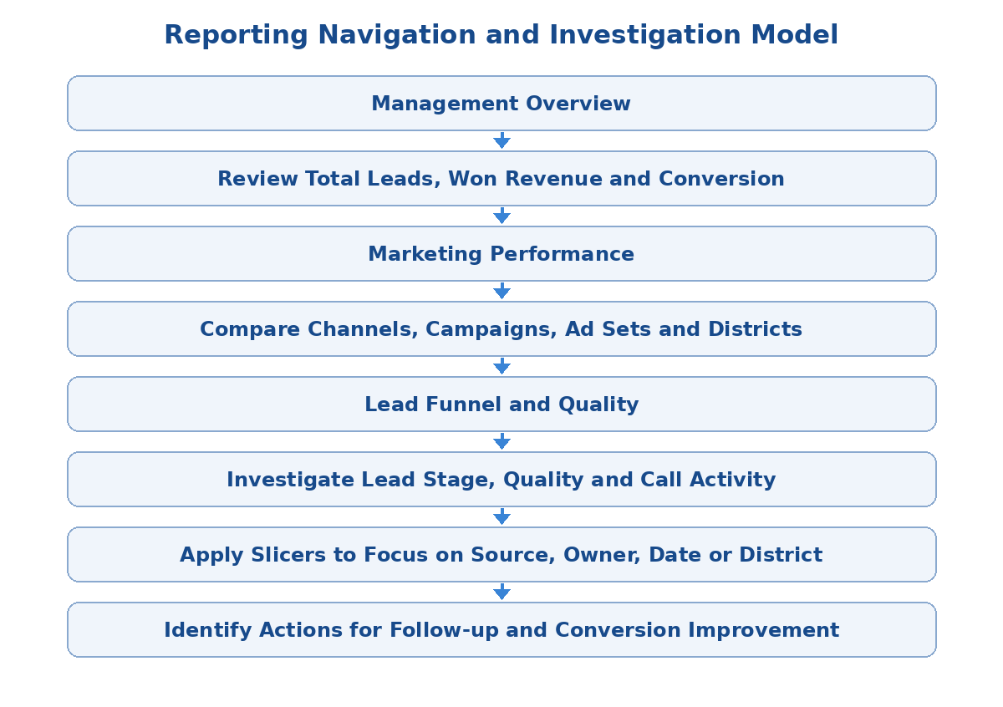
Figure: Suggested navigation path through the three dashboard pages

22. End-to-End System Workflow
- Obtain CRM records in CSV/Excel format.
- Inspect the dataset using Python.
- Identify data-quality issues and clean/validate records.
- Store or query data in PostgreSQL as implemented.
- Connect the selected source to Power BI.
- Apply Power Query transformations.
- Build and validate the Power BI data model.
- Create DAX measures for KPIs.
- Develop the three dashboard pages.
- Compare dashboard values with SQL/Python checks.
- Use findings to improve marketing attribution, lead qualification, and sales follow-up.

Analytical Journey / Business Flow Model
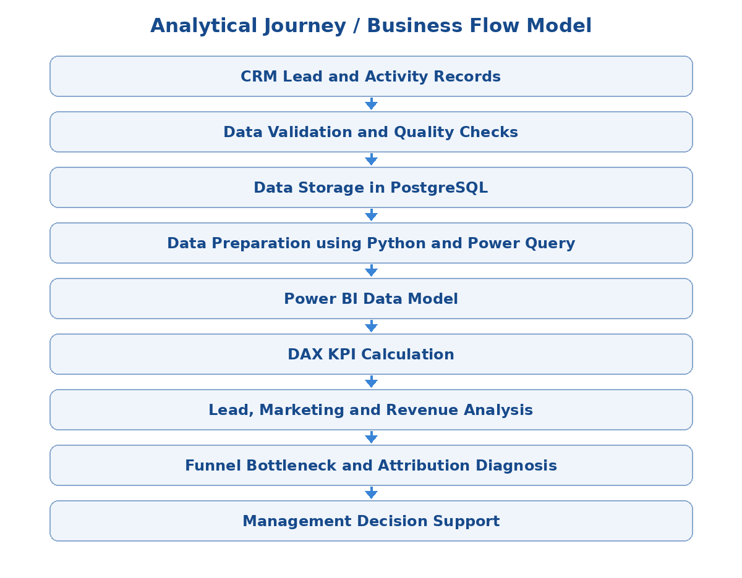
Figure: From CRM records to business diagnosis and decision support

23. Testing and Validation
- Record-count validation: compare Power BI lead totals with source data.
- Identifier validation: check whether Lead ID is unique and whether distinct counting is required.
- Revenue validation: reconcile won revenue with source data and SQL/Python results.
- Conversion validation: confirm numerator and denominator use consistent filters.
- Stage validation: verify category names and distinguish funnel stages from final outcomes.
- Date validation: check month ordering, missing months, and date fields used in visuals.
- Category validation: investigate Unknown, Other, No Ad Set, and No Campaign.
- Filter validation: confirm slicers affect intended visuals consistently.
- Visual validation: review labels, sorting, axes, tooltips, and totals.
- Refresh validation: confirm source changes appear after refresh.

24. Limitations and Assumptions
- Findings are based on the supplied dashboard screenshots and have not been independently recalculated from the final dataset.
- The exact definitions of call-activity statuses require business confirmation.
- Unknown lead quality may represent missing information or a legitimate category.
- The Other district grouping limits geographic detail.
- Missing campaign and ad-set attribution may affect marketing analysis.
- Lead counts and activity counts must not be treated as interchangeable.
- Revenue currency and calculation logic must be confirmed.
- Advertising cost data is not shown, so Cost Per Lead and Return on Advertising Spend cannot be reliably calculated from screenshots alone.
- Actual Power BI relationships and DAX formulas should be checked against the final PBIX.
- Automated refresh and real-time updates should only be documented if implemented.

25. Conclusion
The CRM Leads, Marketing & Sales Performance Analysis System provides an integrated view of lead generation, marketing performance, sales conversion, revenue, lead quality, and call activity.
By applying Python-based data inspection, PostgreSQL querying, Power Query transformations, Power BI modelling, and DAX calculations, the project demonstrates how CRM records can be converted into interactive business intelligence reports.
The dashboards highlight areas for further investigation, including the 1.97% displayed conversion rate, unknown lead-quality classifications, untouched call activity, funnel drop-off, and incomplete marketing attribution.
Recommended next steps are to validate KPI definitions, improve lead-quality classification, strengthen follow-up recording, investigate funnel drop-off, and improve campaign attribution. These steps can improve reporting reliability and support better-informed marketing and sales decisions.

Note: This is the logical workflow. The exact source-to-Power BI connection should match the connection actually implemented in the project.

